Mask Mate Ear Savers
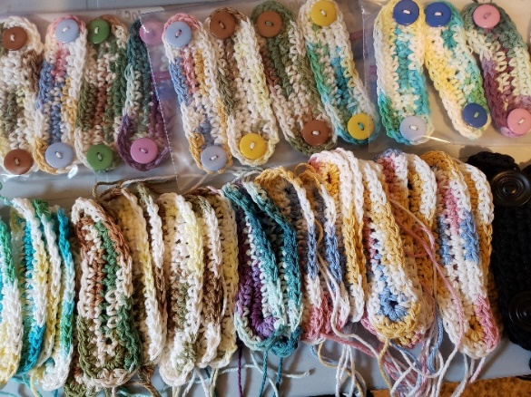
As businesses reopen from the pandemic shutdown, workers are required to wear face masks which attach around the ears. Some workers have sore ears and blisters. Ear savers for relief. Central District LWMLC is launching a mission service project “Mask Mate Ear Savers” encouraging the Central Region LCC congregation members to help make these masks. Some may crochet, knit, sew on buttons, others may provide yarn and buttons. We ask that you report on how many ear savers were made and to whom they were given to. (hair dressers, chiropractors, grocery clerks, home care workers, lab workers, hospital workers etc) Email Arletta Wood, arletta@sasktel.net or text or phone 306-536-5965 with this information. The patterns and standards are in this article
Standards: Small = 4 1/2" (no smaller than this); Medium = 5"; Large = 5 1/2"
Button Style: FLAT Backed only, no shank style buttons or crocheted buttons, no wooden buttons
Button Size: 3/4” and 1” are preferred, can use up to 1 ¼” but no smaller than ¾”
Yarn: Cotton yarn preferred. No wool yarn.
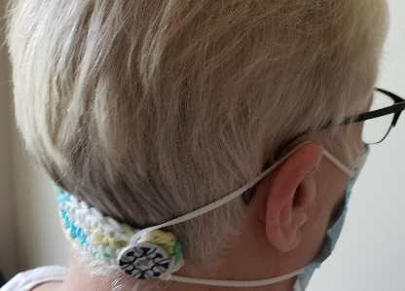
Crochet Pattern Mask Mate Ear Saver
Abbreviations
§ Ch – chain, Fasten Off – chain 1, pull loop out
- Hdc – half double crochet, Sc – single crochet
- Sl st – slip stitch, Slip knot, St, sts – stitch, stiches
Base Pattern
Make slip knot, leaving long (roughly 10 inch) tail at beginning, do not weave or crochet this in.
Use H/5.00mm hook, ch 13.
Round 1: 2 hdc in 2nd ch from hook, 1 hdc in each remaining ch across, place 4 additional hdc in
end chain (5 total), turn 180 degress (do not flip to back), 1 hdc in each remaining loop working
up other side of ch, place 3 addition hdc in end/starting chain (5 total), sl st into first hdc made (30 hdc)
Round 2: ch 1, 2 sc in first st, 1 sc in each of next 12 sts, 2 sc in each of next 3 sts (three sts on
end), 1 sc in each of next 12 sts, 2 sc in each of the next two sts, sl st into top of first sc (36 sc)
Fasten off, leaving long (roughly 10 inch) tail.
(You can replace Round 1 hdc stitch with sc stitch. This will be a tighter weave.)
Finished Size When finished, ear savers measure about 5 inches long. Adjust your number of chains for smaller or larger sizes.

Knit Pattern Mask Mate Ear Saver
Worsted or cotton yarn
Size 4US needle
Tapestry needle, 2- 1" buttons
Worked flat. Cast on 20 stitches with a cable cast on. You want a *slightly* stretchy edge, but some firmness. Knit 11 rows of garter, being sure to slip the first stitch each row for a neat, firmer edge.
Bind off semi-loosely. Tug gently to make sure cast on and bind off have similar amounts of
stretch. *Make sure your bind off tail is on the opposite side than the cast on tail! You'll use the tails to
attach your buttons!* Weave your tails lightly over to the center of each end and sew on buttons. Darn away tails on the wrong side.

